30W Outdoor Music Horn Speaker (15W-30W)
FOH-30
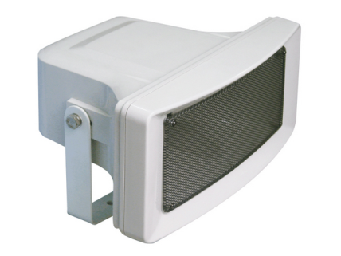
Feature:
- Commercial public address (PA) system use paging horn speaker
- Outdoor use music & paging horn speaker with transformer
- Ideal for outdoor BGM and speech use in school, office, hotel and airport
- Superior sound quality rang weatherproof horn speaker
- Rated power output 15W-30W at 100V
- Waterproof level of IP66
- Line input 100V and 70V
- UV protected ABS enclosure and stainless metal bracket in white
- Quick installation by supplied stainless mounting bracket

Specification:
Model | FOH-30
Description | 30W Outdoor Music Horn Speaker
Rated Power Output | 15W-30W
Line Input | 100V or 70V
Frequency Response | 100-10KHz
SPL(@1W/m) | 97dB
IP Rate | IP66
Connector | By waterproof finish speaker table
Dimension | 366(W)×272(D) ×165(H)mm
Net Weight | 3kg
Material | UV protected ABS enclosure and stainless metal bracket in white
Mounting Way | Quick installation by supplied stainless mounting bracket

Side View, Dimension & Freq VS SPL Diagrams:
